Let’s upgrade

Assignment Day 6

**Question 1**

1. Use PS to search for the “systemd” process by name.

2. Find out your terminal name. Using your terminal name, use PS to find all processes associated

With your terminal.

3. Check and note the process id of your shell (from the output of the above command).

Also, note the parent process id of your shell.

4. Start 3 instances of “sleep 123” as background processes.

5. Check and note the process id’s of all sleep processes.

6. Display only those three sleep processes in top. Then quit top.

Answer 1.

Use PS to search for the “systemd” process by name.

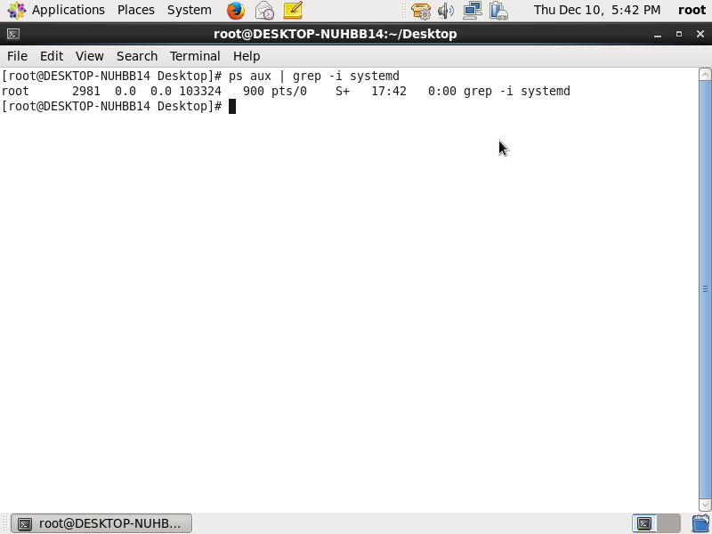

Answer 2.

. Find out your terminal name. Using your terminal name, use PS to find all processes associated

With your terminal.

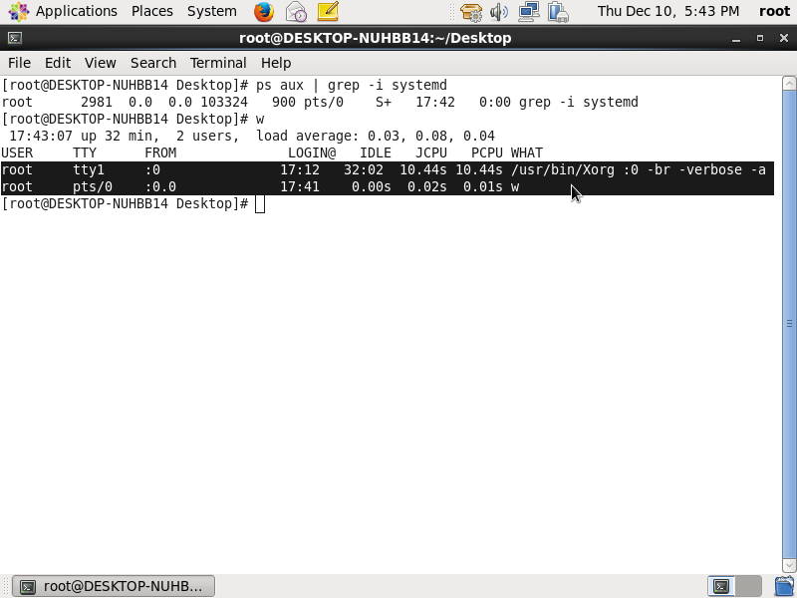

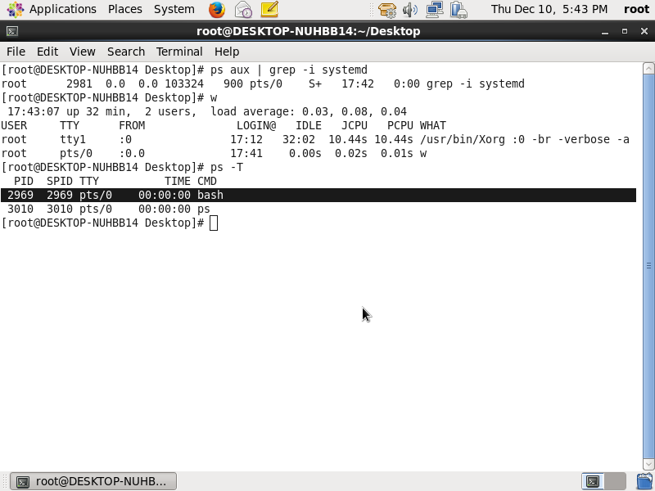

Answer 3.

Check and note the process id of your shell (from the output of the above command). Also, note the parent process id of your shell.

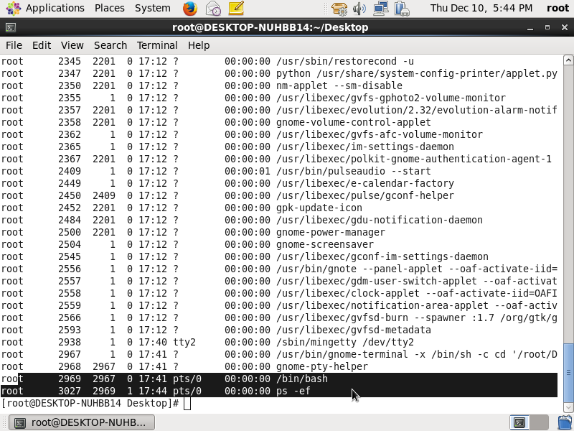

Answer 4.

Start 3 instances of “sleep 123” as background processes.

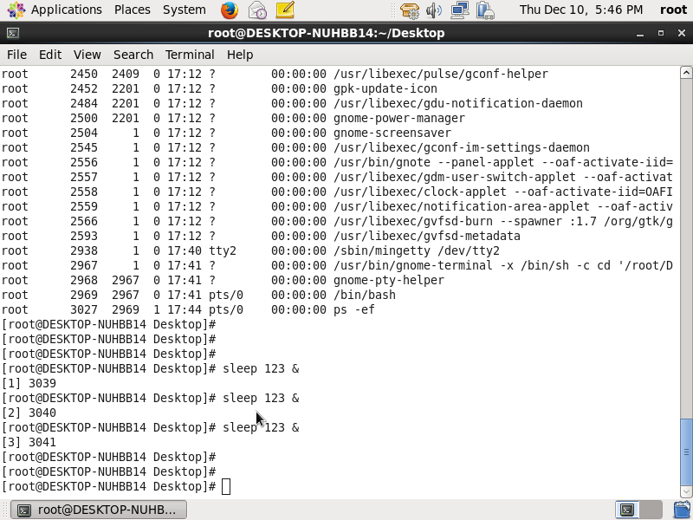

Answer 5.

Check and note the process id’s of all sleep processes. And the process ids are 3039, 3040, 3041

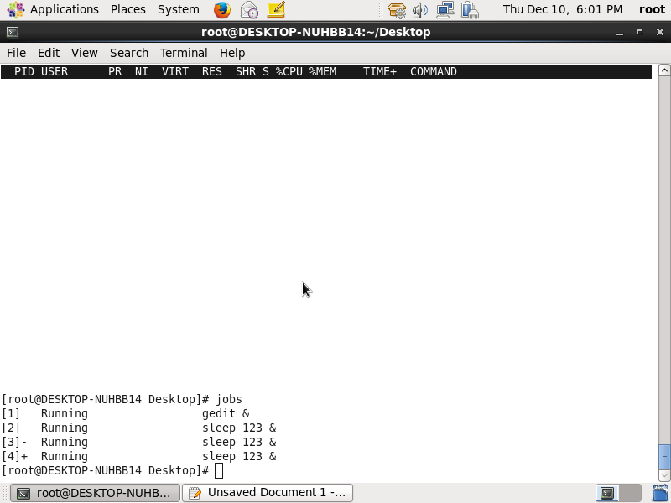

Answer 6.

Display only those three sleep processes in top. Then quit top.

And the background process show by jobs command



And then Quit by pressing “q” key.

